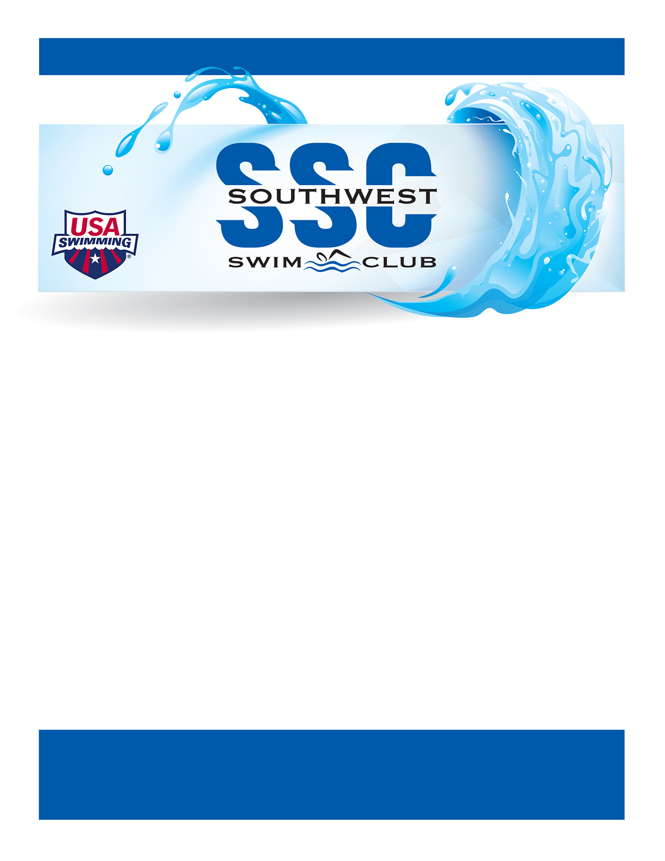


TRY-OUTS FOR NEW
SWIMMERS:

Monday,
September 22
OR
Tuesday,
September 23

7-7:30pm
at the SMSU pool

Swimmers should bring a swimsuit, towel, & goggles.

If unable to attend, please contact Connie Dunn at dunnc6@hotmail.com to arrange a different try-out date/time.
Southwest Swim Club (SSC) proudly offers developmentally appropriate competitive swimming instruction for swimmers ages 6-18 years old. SSC is a USA-Swimming member. All meets and practices are governed by USA Swimming and conducted by registered, professional coaches.

Swim practices are held Monday through Thursday at the SMSU pool from 7-8pm until mid-November. Starting mid-November, practices will be held from 5-6:30pm. Swimmers will be divided into practice groups based on ability level. Swim practices range from 30 minutes to 90 minutes depending on the practice group. The practice schedule will vary based on other swim meets, holidays, weather, and pool maintenance.

Fees vary based on group assignments. All swimmers are required to pay annual USA Swimming registration fee in addition to team dues. Swim meets are encouraged but not required, additional fees for entries apply for those events.

Our Fall/Winter season begins on Monday, September 29, 2025, and ends on Thursday, February 26, 2026.

Check out our Facebook page!
Southwest Swim Club - Marshall MN
QUESTIONS?
Contact Connie Dunn at dunnc6@hotmail.com
Check us out online at: www.teamunify.com/msswsc

SSC INVITES YOU TO JOIN US FOR A GREAT SEASON!

